**MYOB Coding Exercise by Herman Gouw**

* This file is located on **MyobCodingExercise\ MYOB Coding Exercise.pdf**
* This solution was done using **Visual Studio 2015, C# 6 and .NET Framework 4.6**

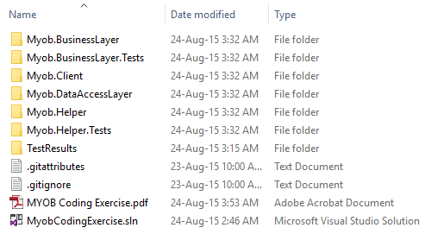

* The executable file is located on **MyobCodingExercise\Myob.Client\bin\Debug\Myob.Client.exe**
* The input file is located on **MyobCodingExercise\Myob.Client\Data\input.csv**
* The test harnesses (unit testings) are provided in **Myob.BusinessLayer.Tests** and **Myob.Helper.Tests**
* The following assumptions were made in this solution:

1. The input data (containing a list of employee details) will be read from the filename input.csv
2. There is no validation done on the input file data
3. The output data (containing a list of employee payslips) will be written in the filename **output.csv** (in the same location as the input data)

* To run the application

1. click on **MyobCodingExercise\Myob.Client\bin\Debug\Myob.Client.exe**

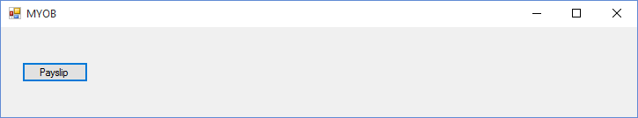

1. click on the Payslip button and select the filename **input.csv**

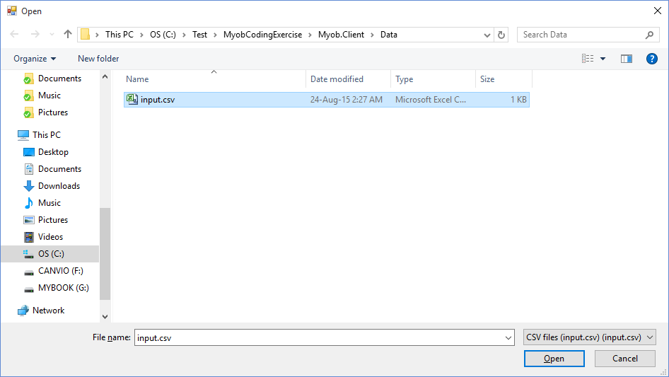

1. after the payslip has been generated the corresponding message will be displayed

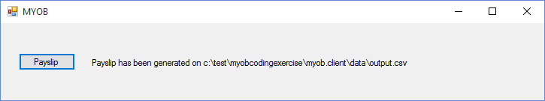

1. check the contents of the filename **output.csv**